Genetics Review Project: Central Dogma Review

Step 1 [1 stamp]: Decode Mr. Warren’s amino acid message from the “Coding DNA” sequence labeled below.
- Apply the DNA→DNA base-pairing rules to fill in the complementary “Template” strand of DNA.
- Apply the DNA→RNA base-pairing rules to fill in the complementary strand of RNA
- Use the codon chart to determine the amino acid sequence from the strand of RNA (3 bases at a time)
Coding DNA | ATG | ATC | CAT | GAA | GCG | CGC | ACC | AGC | TGC | ATT | GAA | AAC | TGC | GAA | TAG
Template DNA | TAC
RNA | AUG
Amino Acids | START

Step 2: In pairs or individually, make your own Amino Acid message using the 1-letter abbreviations for the 20 different amino acids.

- 10-16 letters long and school appropriate
- You may NOT use the following letters: B, J, O, U, X, Z (there are no amino acids with those abbreviations)
- Every protein starts with the amino acid Methionine. Your message should begin with a [START] codon
- Include a [STOP] codon at the end

Step 3 [1 stamp]: Once you have settled on your message, work backwards to determine the RNA sequence, Template DNA sequence, and Coding DNA sequence.

S

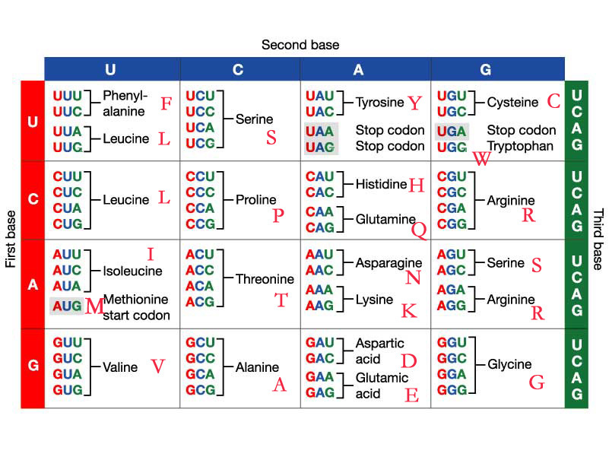
Genetics Review Project : Protein Modeling *READ CAREFULLY!*

Step 4: Figure out how many colored squares you need to spell out your message (including [start]) and get them. Each letter represents one amino acid in your protein chain, and the colors represent different properties based on the amino acids’ individual molecular structures.

The color for each letter matters!!! ***Please color-code your codon chart on the previous page!***

(Yellow): Hydrophobic amino acids: [start], M, A, G, I, L, F, W, Y, V
(Green): Positively charged amino acids: R, H, K
(Red): Negatively charged amino acids: D, E
(Blue): Hydrophilic amino acids: S, T, N, Q, P
(Purple): Amino acids that make disulfide bonds: C

Note: There is no amino acid for [stop]

Step 5: Label each square

On the front side of the square
-Write the letter big and bold with a marker
-On the first amino acid, put your name(s) and period

On the back side, number the squares in order
-Write these numbers small, in one of the corners
(not in the middle, because the pipe cleaner will cover it)
-The first (start) square will be number 1
Step 6: Make your amino acid chain by taping the lettered squares to a pipe cleaner.
-Ask the teacher to let you pick 1 or 2 pipe cleaners (same color).
-If a smaller, un-used piece (of the same color) is available and will fit your message, then use that.
-Twist just the ends together, and tape around the twisted part.
-Tape each letter to the pipe cleaner across the back
-Just use 1 piece of tape per letter, and leave a little space between them (see diagram above)
-DO NOT tape the letter squares together, and DO NOT overlap the squares.
(The pipe cleaner needs to be able to bend between squares).
-Cut off the left over pipe cleaner. If it’s at least a few inches long, we can save it for other students that only need a small piece. Give that piece to the teacher. Otherwise, throw it away.

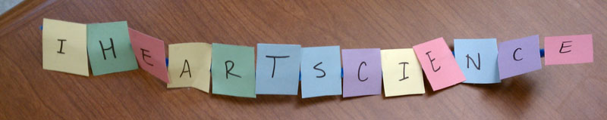

Genetics Review Project: Protein Folding

Step 7: Fold your protein model into a stable 3D structure while keeping all amino acids as happy as possible.

[2 stamps] You must write down a detailed paragraph explaining how you folded the protein based on the following rules:

- If you have at least 2 cysteines (C) in your protein, make sure they are bonded together (use a paperclip)
- Amino acids with opposite charges (+/-) will attract (they like being close together)
- Amino acids with the same charge (+/+ or -/-) will repel (push away from each other)
- Charged & hydrophilic amino acids like being in water (either in the cytoplasm or outside of the cell)
- Hydrophobic amino acids will like being either in the cell membrane (the middle of the cell membrane is also hydrophobic) or together, hiding in the middle of the charged & hydrophilic amino acids so they don't have to touch water.

Blue = Hydrophilic (loves water) Yellow = Hydrophobic (fears water) Purple = Makes very strong
Green = Positively charged (+) Red = Negatively charged (-) disulfide bonds

Tips for folding
- If your protein has a lot of charged & hydrophilic amino acids, I suggest trying to fold your protein so that the hydrophobic amino acids are located in the middle of them.
- If your protein has a lot of hydrophobic amino acids, I suggest trying to do the opposite.
- If you have mostly hydrophobic amino acids on one side of your amino acid chain, I suggest trying to keep the hydrophobic amino acids on one side of the protein and the rest on the other side.

Step 8 [1 stamp]:  Determine and describe your protein’s location and function.  (Only hydrophobic parts of your protein like being in the membrane).  ① Receptor (see “Membrane Receptor” p.84)  ② Channel (see “Transport Protein” p.87)  ③ Enzyme (p.55) or Intracellular Receptor (p.84)  ④ Signal Molecule (see “Ligand” in p.84)  ⑤ Membrane Enzyme (see “Enzyme” p.55)  ⑥ Cell Identification Tag (p.82) | 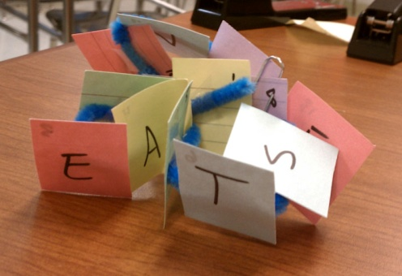

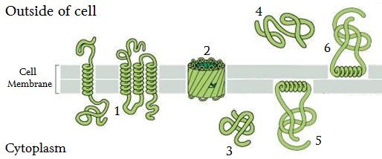
G-1 (15 points): Answer the essential questions in a scroll, booklet, powerpoint, etc.
(ask Mr. Warren about other ideas)
***If working in pairs, you only need to turn in one, but everyone will be tested on this information!***

Essential Question: How does the sequence of DNA nucleotides (A, T, C, and G) in a gene ultimately determine the specific function of the protein that is made?
(this assignment IS your answer to the essential question)

- Explain in 2-3 sentences the process of DNA Replication, including where it occurs and how the nucleotides (A, T, C, G) are paired.
● Provide your example: Write out (and label) your coding DNA and template DNA strands for your protein.

- Explain in 2-3 sentences the process of Transcription, including where it occurs, which DNA strand (coding or template) is used, and how the DNA nucleotides (A, T, C, G) are paired with RNA nucleotides (A, U, C, G).
● Provide your example: Write out (and label) your template DNA and RNA strands for your protein.

- Explain in 2-3 sentences the process of Translation, including where it occurs, & what codons are.
● Provide your example: Write out (and label) your RNA strand and the amino acid sequence for your protein.
  - Make sure it’s easy to see the RNA codons that correspond to each amino acid
  - Color code the amino acids based on their properties

- Explain in 1 sentence (in general) how the sequence of amino acids affects the structure of a protein.
● Support this statement by explaining what chemical properties are represented by each color and how these different properties interact (refer to protein folding rules).
● Provide your example: Describe in a detailed paragraph how you folded your protein model.
  - Explain how the properties (NOT colors) of specific amino acids in your protein model affected the way you folded it. You may refer to individual amino acids by number if that helps.

- Explain in 1 sentence (in general) how the structure of the protein affects the function of that protein.
● Provide your example: Describe where in your protein is located (relative to the cell membrane) and why.
● Describe what kind of protein you have, its location, and its function.

- Conclusion: Summarize in a few sentences how the sequence of DNA determines the function of the protein and why a slightly different DNA sequence could result in an entirely different function.

Genetics Review Project: Mutation Review

Step 9 [1 stamp]: Mutation (notes) (see ch 8.7)  - What are 3 different ways that mutations can occur?  - In which kind of molecule do mutations occur?  - Explain what kind of mutations can be passed onto the offspring (babies) and what kind can’t.  - Are all mutations bad? Can they be helpful? Explain! | Hydrophobic amino acids: M, A, G, I, L, F, W, Y, V  Positively charged amino acids: R, H, K  Negatively charged amino acids: D, E  Hydrophilic amino acids: S, T, N, Q, P  Amino acids that make disulfide bonds: C
Step 10 [1 stamp for each side]: Complete Mr. Warren’s Practice Mutations (next page)
Effects of mutations on the amino acid sequences

Silent |  | Mutation does not change the amino acid sequence
Missense |  | Mutation changes one amino acid into a different one with different properties (like a hydrophobic amino acid changing to hydrophilic)
Neutral |  | Mutation changes one amino acid into a different amino acid with similar properties (like a hydrophobic amino acid changing into a different hydrophobic amino acid)
Nonsense |  | Mutation changes an amino acid into an early STOP
Frameshift |  | Insertion or deletion of 1 or 2 nucleotides changes all of the amino acids thereafter by shifting the “reading frame” for the remaining codons. This shift could also create early or late STOP codons.
Other |  | (If it’s not in any of the above categories, explain the effect)

Step 11 [2 stamps]: Rank the 9 mutations you made to Mr. Warren’s protein in order from the least affected to the most affected. Explain your reasoning! (You are trying to predict how well the protein will function with each of the mutations).

Genetics Review Project: Mutating your protein

G-2 (15 points): Mutation Miniposter (color coding is required for all amino acids!)

Use the coding DNA sequence for your protein (from step 3) to make up a mutation for each of the 5 effects (silent, missense, neutral, nonsense, and frameshift). You may use the format from the mutation practice (step 10) to show where your 5 mutations occurred. Then, write down the codons (RNA) affected by the mutation as well as the full amino acid sequences for each. See example on the back of this page.
***If working in pairs, both of you need to make your own separate mutations to the same protein!***
Rank the 5 mutations you made to your own protein in order from the least affected to the most affected. Explain your reasoning! (You are trying to predict how well your protein will function with each of the specific mutations you made).

