Practice for N-22, N-23, and N-24
Chicken McNuggets  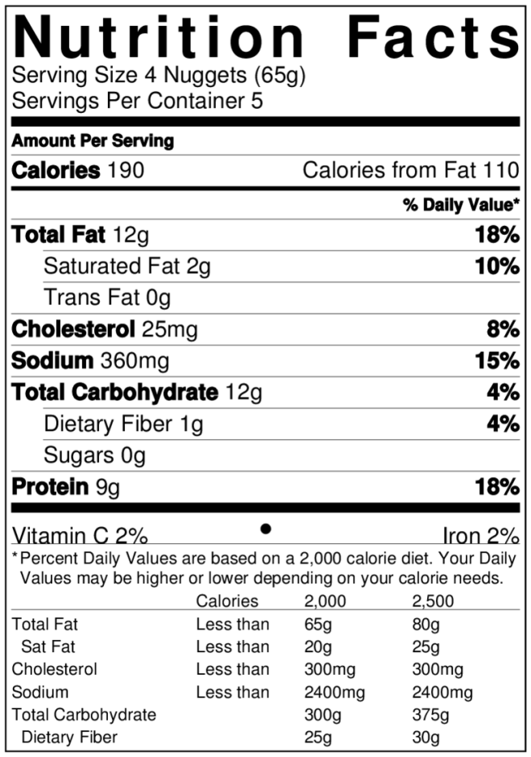  Big Mac  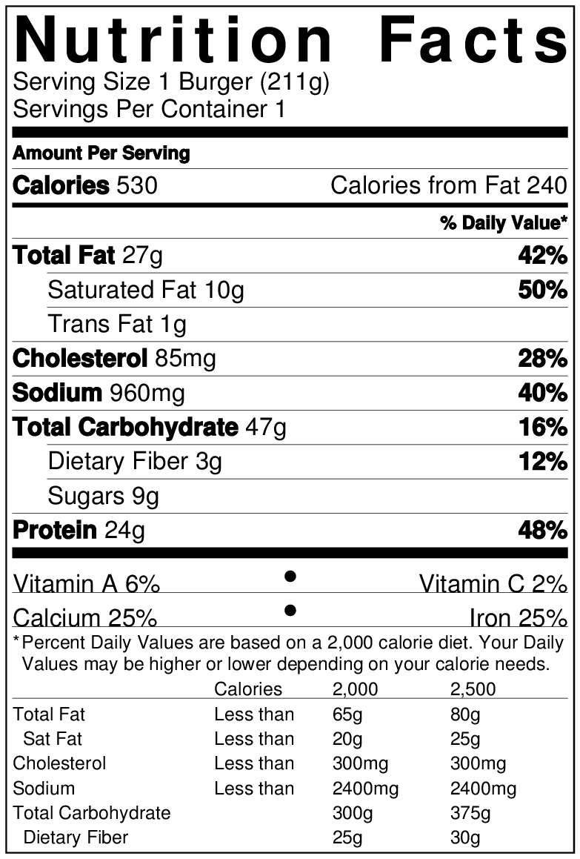 | - How many Chicken McNuggets are in the whole box?  - How many Calories does one McNugget have?  - How many Calories are in the whole box?  - What percent of Calories (out of 2000 Calories) would you consume if you ate the whole box?  - How many McNuggets would you need to eat to reach 2000 Calories?  - For the McNuggets, what percent of Calories are from fat?  (note: you should try to keep your % calories from fat below 30%)  - For the Big Mac, what percent of Calories are from fat?  - What percent of Calories (out of 2000 Calories) would you consume if you ate a Big Mac?  - How many Big Macs would you need to eat to reach 2000 Calories? (Round to 1 decimal place.)  - How many McNuggets would you need to eat to get the same Calories as a Big Mac?  - When comparing nutrient densities, why would it be unfair to compare the numbers in 1 serving of McNuggets versus the numbers in 1 Big Mac?

