Practice for N-22, N-23, and N-24
Chicken McNuggets  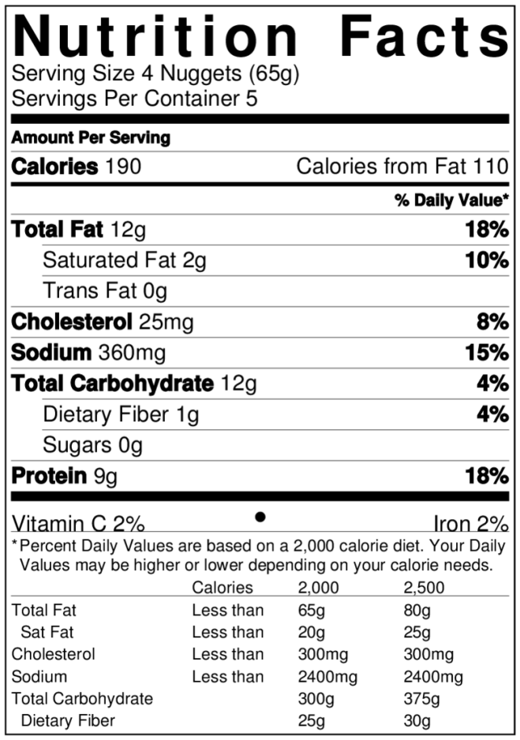  Big Mac  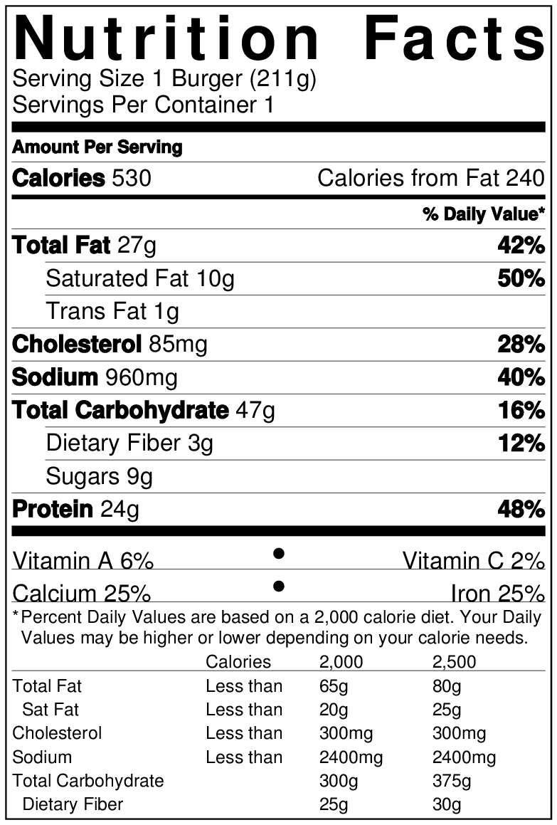 | - How many Chicken McNuggets are in the whole box?  4 nuggets per serving x 5 servings per box = 20 nuggets  - How many Calories does one McNugget have?  190 Cal per serving / 4 nuggets per serving = 47.5 Calories  - How many Calories are in the whole box?  190 Cal per serving x 5 servings per box = 950 Calories  - What percent of Calories (out of 2000 Calories) would you consume if you ate the whole box?  950 Cal / 2000 Cal = 0.475 = 47.5%  - How many McNuggets would you need to eat to reach 2000 Calories?  2000 Cal / 47.5 Cal per nugget = 42 Nuggets  - For the McNuggets, what percent of Calories are from fat?  (note: you should try to keep your % calories from fat below 30%)  110 Cal from fat / 190 total Cal = 0.579 = 57.9%  - For the Big Mac, what percent of Calories are from fat?  240 Cal from fat / 530 Cal per big mac = 0.453 = 45.3%  - What percent of Calories (out of 2000 Calories) would you consume if you ate a Big Mac?  530 Cal per big mac / 2000 Cal = 0.265 = 26.5%  - How many Big Macs would you need to eat to reach 2000 Calories? (Round to 1 decimal place.)  2000 Cal / 530 Cal per big mac = 3.8 Big Macs  - How many McNuggets would you need to eat to get the same Calories as a Big Mac?  530 Cal per big mac / 47.5 Cal per nugget = 11 Nuggets  - When comparing nutrient densities, why would it be unfair to compare the numbers in 1 serving of McNuggets versus the numbers in 1 Big Mac?  Nutrient Density refers to the amount of nutrients compared to the energy (Calories) the food provides. In order to compare the nutrient densities, we must compare the nutrients found in foods of equal amounts of Calories.

