Hot Cheeto Puffs  - How many Calories are in the whole bag?  - How many Calories are in one Cheeto Puff?  - What % of the Calories is from fat?  - What % of your Iron for each day do you get from one serving?  - How many servings would you need in order to get 100% of your iron for the day?  - How many bags of Hot Cheeto Puffs would you need to get that many servings?  - How many Calories would be in that many servings? | 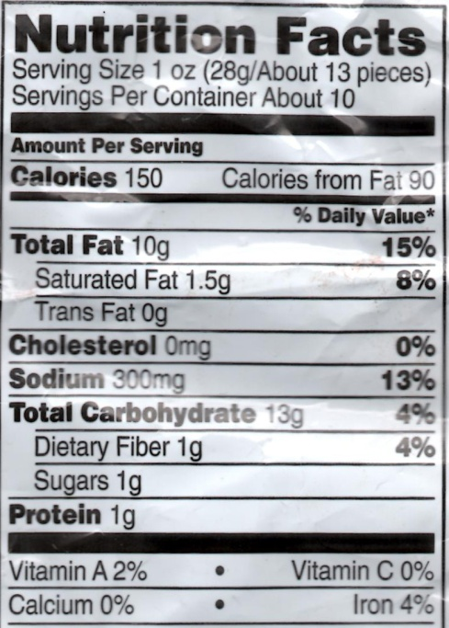
Nutrition Label Practice Calculations (see pgs. 168-169)

Show your work (include what you multiplied/divided to get your answer), and include units!

Cheetos vs. Grapes:
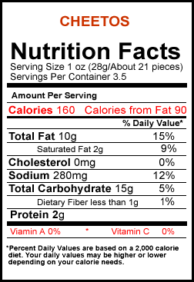 | 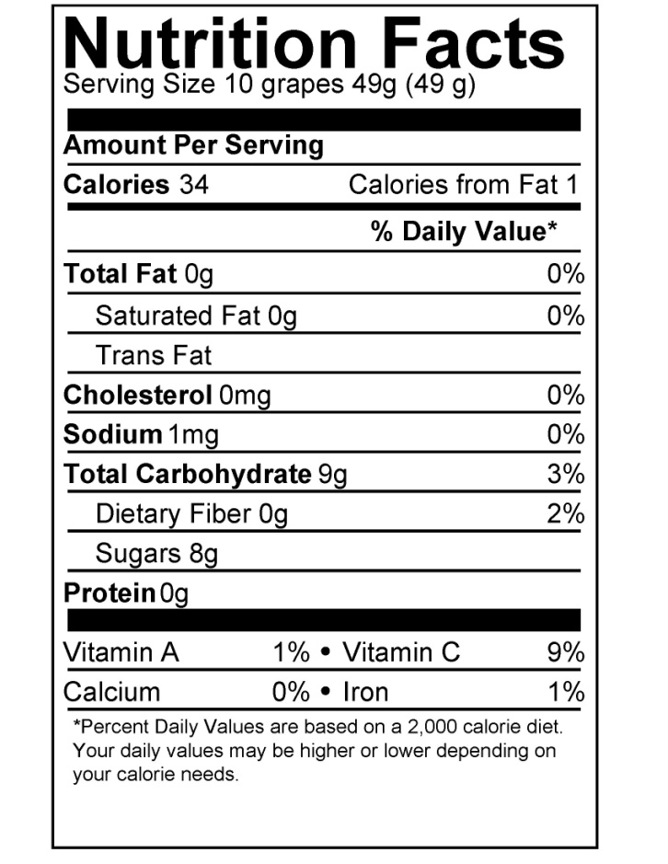

- How many calories are in the whole bag of cheetos?
- How many calories are in one grape?
- How many grapes give you the same amount of calories as the whole bag of cheetos?
- How many grapes do you need to eat to get 100% of your vitamin C for the day?
- How many pieces of cheetos do you need to eat to get 100% of your sodium for the day?

