Nutrition Label Calculations Name:_______________________ Date:_____________ Per:___

- How many cheetos (“pieces”) are in one serving?  (see “Serving Size”)  - How many Calories are in one serving?  (see “Calories”)  - How many Calories are in ONE cheeto?  - How many cheetos would you need to get 100 Calories?  - How many servings are in the whole bag?  (see “Servings Per Container”)  - How many cheetos are in the whole bag?  - How many Calories are in the whole bag?  - How many grams of fat are in one serving?  - How many grams of fat are in the whole bag? | Always show your work  (what you typed into the calculator)  Always show units  (hint: the units for your answers  should match what is in bold)  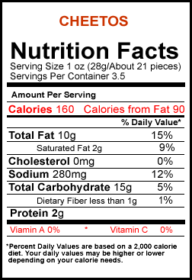

- What % Daily value of total fat do you get from one serving?

- How many servings would you need to eat to get 100% of your fat for the day?

- How many cheetos would you need to eat to get 100% of your fat from the day?

- What percent of your Fiber for each day (%DV) do you get from one serving?

- How many servings would you need in order to get 100% of your Fiber for the day?

- What percent of your daily fat would you get if you ate enough cheetos to reach 100% of your Fiber
for the day?

- How many Calories are in 10 grapes?  - How many Calories are in 1 grape?  - How many grapes would you need to get 100 Calories?  - How many servings would you need to get 100 Calories?  - What percent of your daily vitamin C (%DV) do you get from 1 serving of grapes?  - How many servings of grapes do you need to get 100% of your vitamin C for the day?  - How many grapes do you need to eat to get 100% of the vitamin C for the day? | Grapes  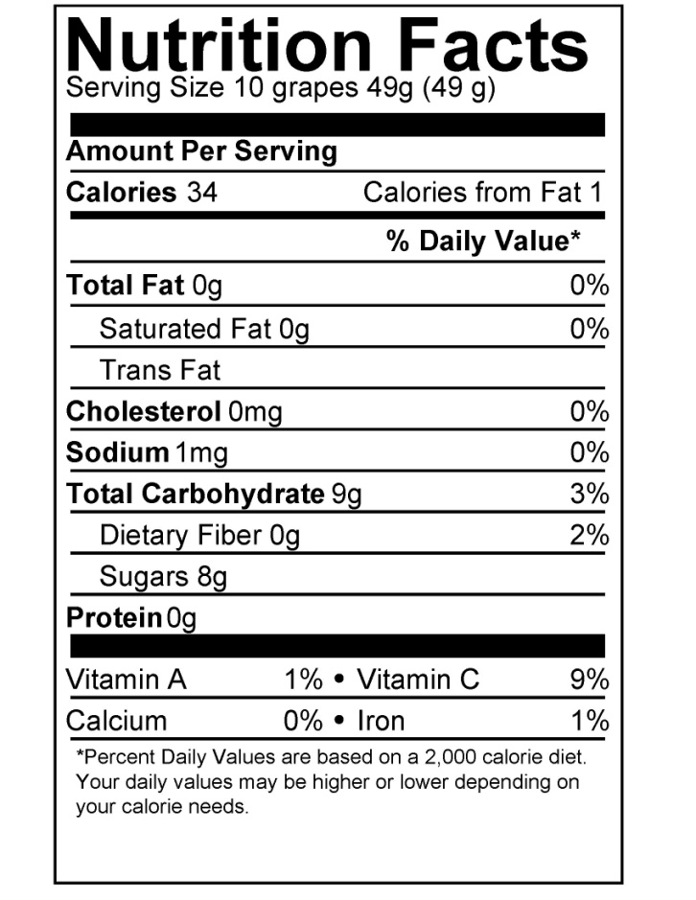

- If there is 1 Calorie from fat, why does the label say there’s 0g fat?

24) How do you get 2% of your daily fiber from a serving of grapes if there are 0g of fiber?

D-2: This is 100 Calories (+5-7* extra credit points)
- Choose a food of your choice to bring to class.
- Use the nutrition label to calculate the amount of that food that provides 100 Calories.
- Bring to class your math on paper (show your work, and include units), the nutrition label, and 100 Calories worth of that food in a zip-loc bag to be displayed in the class.
- You may not choose a food that already comes packaged in servings of 100 Calories.
- If the food you bring needs to be weighed because it does not show the serving size as a number of pieces, Mr. Warren can provide a scale.
- You may not choose any food that has already been turned in before you.
- *Bonus: Calculate the number of pieces that is supposed to be in the whole container, and then count how many pieces are actually there. Include the math (show work, and include units) and the amount you counted on your paper for +2 pts.
More Nutrition Label Practice Calculations
Show your work (include what you multiplied/divided to get your answer), and include units!

Chicken McNuggets  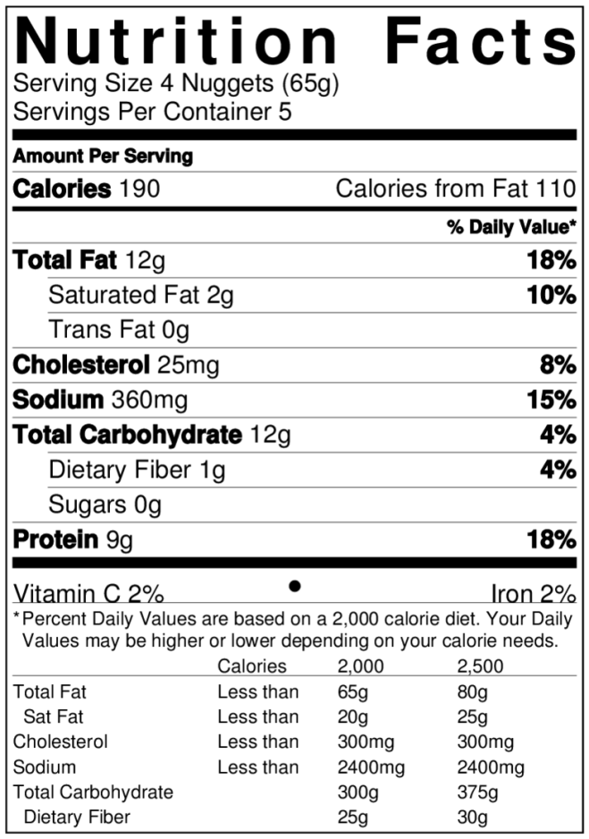  Big Mac  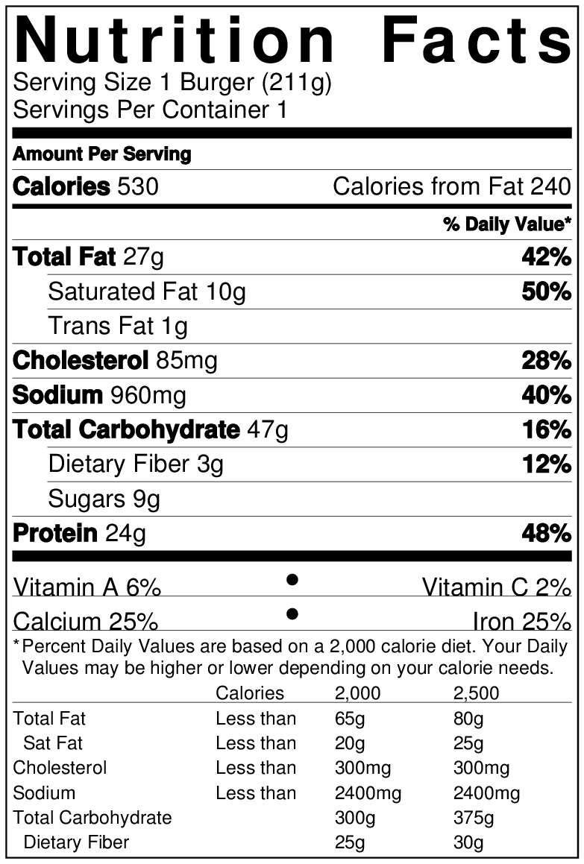 | - How many Chicken McNuggets are in the whole box?  4 nuggets per serving x 5 servings per box = 20 nuggets  - How many Calories does one McNugget have?  190 Cal per serving / 4 nuggets per serving = 47.5 Calories  - How many Calories are in the whole box?  190 Cal per serving x 5 servings per box = 950 Calories  - What percent of Calories (out of 2000 Calories) would you consume if you ate the whole box?  950 Cal / 2000 Cal = 0.475 = 47.5%  - How many McNuggets would you need to eat to reach 2000 Calories?  2000 Cal / 47.5 Cal per nugget = 42 Nuggets  - For the McNuggets, what percent of Calories are from fat?  (note: you should try to keep your % calories from fat below 30%)  110 Cal from fat / 190 total Cal = 0.579 = 57.9%  - For the Big Mac, what percent of Calories are from fat?  240 Cal from fat / 530 Cal per big mac = 0.453 = 45.3%  - What percent of Calories (out of 2000 Calories) would you consume if you ate a Big Mac?  530 Cal per big mac / 2000 Cal = 0.265 = 26.5%  - How many Big Macs would you need to eat to reach 2000 Calories? (Round to 1 decimal place.)  2000 Cal / 530 Cal per big mac = 3.8 Big Macs  - How many McNuggets would you need to eat to get the same Calories as a Big Mac?  530 Cal per big mac / 47.5 Cal per nugget = 11 Nuggets  - When comparing nutrient densities, why would it be unfair to compare the numbers in 1 serving of McNuggets versus the numbers in 1 Big Mac?  Nutrient Density refers to the amount of nutrients compared to the energy (Calories) the food provides. In order to compare the nutrient densities, we must compare the nutrients found in foods of eqal amounts of Calories.

If you’re struggling with what numbers to multiple or divide, this list can help you. However, the goal is for you to understand how to do the calculations--not just to get the right answers for these practice problems on your paper.

- Find Serving size (pieces)
- Find Calories (amount per serving)
- Calories (per piece) = Calories (amount per serving) / Serving size (pieces)
- Pieces (for 100 Calories) = 100 Calories / Calories (per piece)
- Find Servings Per Container
- Pieces per container = Serving size (pieces) x Servings per container
- Calories per container = Calories (amount per serving) x Servings per container
- Find Total Fat (g)
- Fat (g) per container = Total Fat (g per serving) x Servings per container
- Find Total Fat (% Daily Value)
- Servings (for 100% fat) = 100% / Total Fat (%DV)
- Pieces (for 100% fat) = Servings (for 100% fat) x Serving size (pieces)
- Find Dietary Fiber (% Daily Value)
- Servings (for 100% Fiber) = 100% / Dietary Fiber (%DV)
- % Fat = Servings (for 100% Fiber) x Total Fat (%DV)
- Find Calories (amount per serving)
- Calories (per grape) = Calories (amount per serving) / Serving Size (grapes)
- Grapes (for 100 Calories) = 100 Calories / Calories (per grape)
- Servings (for 100 Calories) = 100 Calories / Calories (amount per serving)
- Find Vitamin C (% Daily Value)
- Servings (for 100% Vitamin C) = 100% / Vitamin C (%DV)
- Grapes (for 100% Vitamin C) = Servings (for 100% Vitamin C) x Serving Size (grapes)
- Thinking Question?
- Thinking Question?
- Chicken McNuggets (per box) = Servings Per Container x Serving Size (Nuggets)
- Calories (per Nugget) = Calories (amount per serving) / Serving Size (Nuggets)
- Calories (per box) = Calories (amount per serving) x Servings per container
- % of 2000 Calories = Calories (per box) / 2000 Calories (…then convert decimal to percent)
- Nuggets (for 2000 Calories) = 2000 Calories / Calories (per Nugget)
- % Calories from fat = Calories from Fat / Calories (amount per serving) (…then convert decimal to percent)
- % Calories from fat = Calories from Fat / Calories (amount per serving) (…then convert decimal to percent)
- % of 2000 Calories = Calories (Amount per serving) / 2000 Calories (…then convert decimal to percent)
- Big Macs (for 2000 Calories) = 2000 Calories / Calories (Amount per serving)
- Nuggets (per big mac) = Calories (per big mac) / Calories (per nugget)
- Thinking Question?

Answer Key:
- 21 cheetos
- 160 Calories
- 160/21 = 7.6 Calories
- 100/7.6 = 13.2 cheetos
- 3.5 servings
- 21 x 3.5 = 73.5 pieces
- 160 x 3.5 = 560 Calories
- 10g Fat
- 10 x 3.5 = 35g Fat
- 15% Fat
- 100%/15% = 6.7 servings
- 6.7 x 21 = 141 cheetos
- 1% Fiber
- 100%/1% = 100 servings
- 100 x 15% = 1500% Fat ( that’s 15 days worth of fat to get 1 day worth of fiber)
- 34 Calories
- 34/10 = 3.4 Calories
- 100/3.4 = 29 grapes
- 100/34 = 2.9 servings
- 9% Vitamin C
- 100/9 = 11 servings
- 11 x 10 = 110 grapes
- The number is so small, it rounds down to 0
- There is fiber in it, but the number is so small it rounds down to 0
- 5x4 = 20 Nuggets
- 190/4 = 47.5 Calories
- 190 x 5 = 950 Calories
- 950/2000 = 0.475 = 47.5% of your day’s Calories
- 2000/47.5 = 42 Nuggets
- 110/190 = 0.579 = 57.9% Calories from fat
- 240/530 = 0.453 = 45.3% Calories from fat
- 530/2000 = 0.265 = 26.5% of your day’s Calories
- 2000/530 = 3.8 Big Macs
- 530/47.5 = 11 Nuggets
- Nutrient Density refers to the amount of nutrients compared to the energy (Calories) the food provides. In order to compare the nutrient densities, we must compare the nutrients found in foods of equal amounts of Calories.

